**R Code for Examples in the book**

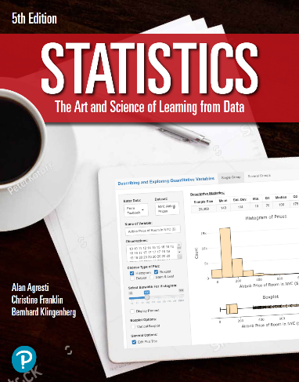

***“Statistics: The Art and Science of Learning from Data”***

**by Agresti, Franklin and Klingenberg, 5th edition**

**Chapter 8**

**Example 9: Using t-Distribution for Confidence Interval for the Mean**

## Reading in data

x <- c(540, 565, 570, 570, 580, 590, 590, 590, 595, 610, 620)  
n <- length(x)  
xbar <- mean(x)  
s <- sd(x)  
se <- s / sqrt(n)

## To compute the t-score for a confidence level of 95% and n-1 degrees of freedom

tscore <- qt(0.975, df = n-1)

## To compute a 95% confidence interval for the population mean

me <- tscore * se  
xbar + c(-1, 1) * me

## [1] 568.7583 598.5144

## Alternatively, you can also use the t.test() function

t.test(x, conf.level = 0.95)

##   
## One Sample t-test  
##   
## data: x  
## t = 87.406, df = 10, p-value = 9.399e-16  
## alternative hypothesis: true mean is not equal to 0  
## 95 percent confidence interval:  
## 568.7583 598.5144  
## sample estimates:  
## mean of x   
## 583.6364